# Lab: Modules

## Calculate Logarithm

Write a program that **prints** the calculated logarithm of **any** given number.

### Input

* On the **first** line you will **receive** the **number** (an integer).
* On the **second** line you will **receive** a number, which is the **base** of the logarithm. It can be **either** a number or the word "natural".

The **output** should be **formatted** to the **2nd** decimal digit

### Examples

|  |  |
| --- | --- |
| **Input** | **Output** |
| 10  natural | 2.30 |
| **Input** | **Output** |
| 10  10 | 1.00 |

### Hints

Use the **math** module. You can read more about it here - <https://www.tutorialsteacher.com/python/math-module>

1. **Import** the module:



1. **Read** the variables:

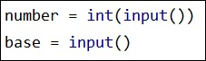

1. Implement the logic:

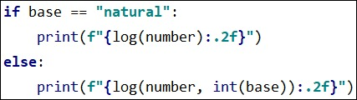

## ASCII Art

Write a program that **encrypts** **given words** by using the characters: "-|_/\()" to structure the word. Use the **pyfiglet** module. You can read more about it here - <https://www.geeksforgeeks.org/python-ascii-art-using-pyfiglet-module/>

### Directions

1. First you need to **install** the module that we will be using. To install it go to **Setting** --> **Project**: <your_project_name> --> **Project Interpreter** --> + --> **search for pyfiglet** --> **install package**.
2. Import the module.
3. Implement the logic. We will be using the **figlet_format** method.

### Examples

|  |  |
| --- | --- |
| **Input** | **Output** |
| Hello World! |  |
| **Input** | **Output** |
| Python 3.8 |  |

### Hints

1. First we need to **import** the module:



1. Then we implement the logic:

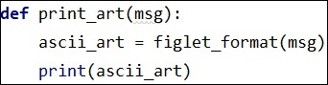

1. Lastly we **print** the message.

## Triangle

Create a **module** for printing a triangle. You will **receive** an integer **number** which is the **size** of the triangle.

### Examples

|  |  |
| --- | --- |
| **Input** | **Output** |
| 3 | 1  1 2  1 2 3  1 2  1 |
| **Input** | **Output** |
| 4 | 1  1 2  1 2 3  1 2 3 4  1 2 3  1 2  1 |

### Hints

1. We'll start with **creating a package** called triangle:

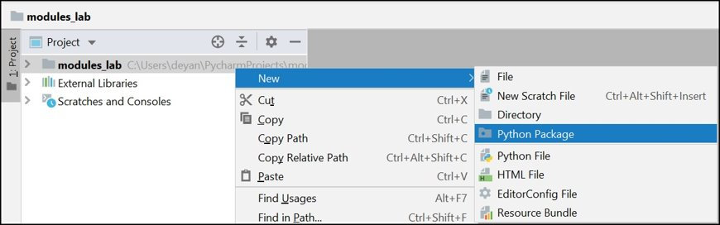

1. Then we implement the logic. You can use 2 nested loops **one** starting from 1 and **another** starting from our limit, each printing a line per cycle:

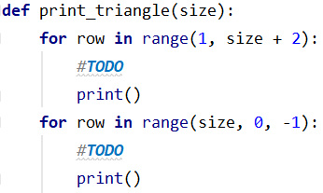

1. And finally, **import** the module:

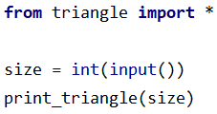

## Mathematical operations

Create a **module** that does basic calculations. You will **receive** 2 numbers and a sign between them all in **one string**.

### Input

You will **receive** a single **string** in the following **format**:

**"{number1} {sign} {number2}"**

* **number1 –** a float number in the range (0.0, 1000.0)
* **sign –** a char that can be:  
  '/' - divide the first number with the second  
  '*' - multiply the 2 numbers   
  '-' - subtract the first number with the second  
  '+' - add the 2 numbers  
  '^' - raise the first number to the second
* **number2 –** an integer number in the range (0, 1000)

### Output

**Print** only the **result** of the operation.

The result should be **formatted** to the **second** decimal point.

### Examples

|  |  |
| --- | --- |
| **Input** | **Output** |
| 2.5 * 2 | 5.00 |
| **Input** | **Output** |
| 6.66 ^ 2 | 44.35 |
| **Input** | **Output** |
| 36.66 / 6 | 6.11 |

## Fibonacci Sequence

Create a **module** that can **create** a **Fibonacci sequence** up to a number (**count of numbers in the sequence**) and **print** them, separating them with a **single space**. The module should also be able to **locate a specific number** in the sequence. You can **read** more about the Fibonacci sequence **here**: <https://en.wikipedia.org/wiki/Fibonacci_number>

You will be receiving **commands** until the "**Stop**" command. The commands are:

* "**Create Sequence {count}"**. Create series of numbers up to a specific **count** and **print** them in the **following format**:  
   **"{n1} {n2} … {n}"**
* "**Locate {number}"**  
  Check if the sequence **contains** the number.If it **finds** the number it should **print**:

**"The number - {number} is at index {index}"**

And if it **doesn't find** it:

"**The number {number} is not in the sequence**"

### Input

* You will be receiving **commands** until the "**Stop**" command. All inputs will be **valid**.

### Output

* **Print** the **output** of every **command** in the **format** **described** **above**.

### Examples

|  |  |
| --- | --- |
| **Input** | **Output** |
| Create Sequence 10  Locate 13  Create Sequence 3  Locate 10 | 0 1 1 2 3 5 8 13 21 34  The number - 13 is at index 7  0 1 1  The number 10 is not in the sequence |